**(DRAFT)**

**WEDNESDAY, FEBRUARY 12TH**

8:00 A.M. CONTINENTAL BREAKFAST

9:15 A.M. CRITICAL INFRASTRUCTURE AND

WATER ON THE HIGHLINE – STAN

SCHWEISSING, CIVIL ENGINEER

MANAGER, HDR

10:00 A.M. CASE STUDY AND PRACTICAL

CONSTRUCTION APPLICATION

APPLICATIONS – CHAD MORGAN,

PEAK WATER SERVICES

11:00 A.M. WHAT CAN WE EXPECT FROM

WASHINGTON – BRETT SLAUGHTER,

GREAT FALLS OFFICE MANAGER

FOR SENATOR STEVE DAINES

11:30 P.M. CLOSING AWARD LUNCHEON

AND RAFFLE

**CONFERENCE REGISTRATION**

------ CUT HERE AND SEND TO MWRA ------

NAME(S) _____________________________

_____________________________________

REPRESENTING ______________________

ADDRESS ____________________________

CITY ______________ STATE ___ ZIP _____

EMAIL ADDRESS ______________________

REGISTRATION COST ($160) ……. $______

SPOUSE REGISTRATION ($110) … $______

TOTAL AMOUNT ENCLOSED …….. $______

**

FOR ROOM RESERVATIONS, CALL FAIRFIELD INN NORTH AT 406-449-3000.

PLEASE REGISTER PRIOR TO FEBRUARY 6TH.

SEND REGISTRATIONS TO MONTANA WATER RESOURCES ASSOCIATION, P. O. BOX 4927, HELENA, MT 59604.

**MONTANA WATER RESOURCES ASSOCIATION**

**P.O. BOX 4927**

**HELENA, MONTANA 59604**

**\*\*\*\*\*\*\*\*\*\*\*\*\*\*\*\*\*\*\***

**\*\*\*\*\*\*\*\*\*\*\*\*\*\*\*\*\*\***

**2025 ANNUAL CONFERENCE**

**AGENDA**



**FEBRUARY 11-12, 2025**

**FAIRFIELD INN NORTH**

**HELENA, MONTANA**

**\*\*\*\*\*\*\*\*\*\*\*\*\*\*\*\*\*\***

## **(DRAFT)**

## **MONTANA**

## **WATER RESOURCES**

## **ASSOCIATION**

**2025**

**Annual Conference Agenda**

**TUESDAY, FEBRUARY 11th**

8:00 A.M. REGISTRATION OPENS

10:00 A.M. MWRA MEMBERSHIP AND WINTER

BOARD MEETINGS

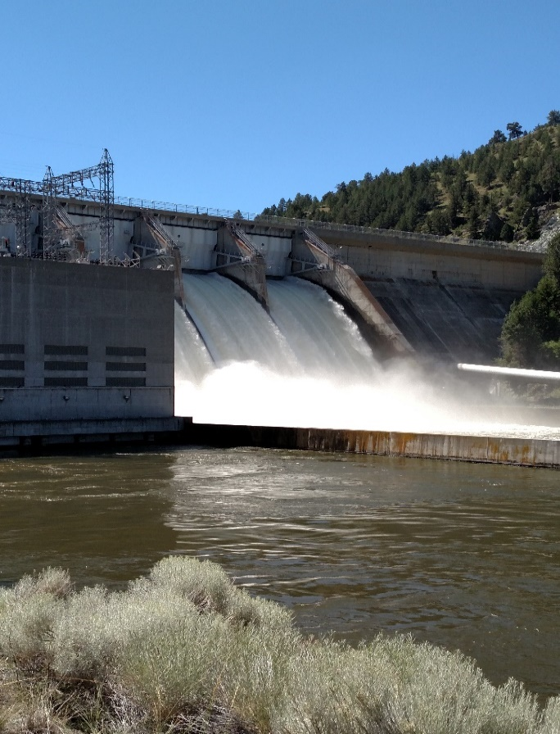

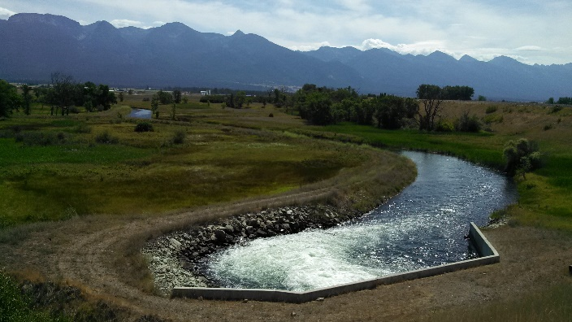

**TUESDAY, FEBRUARY 11th**

12:00 A.M. OPENING LUNCHEON – SPEAKER

GREG MORRISON, EXECUTIVE VICE

PRESIDENT, NATIONAL WATER

RESOURCES ASSOCIATION

1:15 P.M. WELCOME – COLE PEEBLES,

PRESIDENT, MONTANA WATER

RESOURCES ASSOCIATION

1:30 P.M. ADDRESSING MONTANA WATER

ISSUES ON BEHALF OF MONTANA

WATER USERS – AMANDA KASTER,

DIRECTOR, MONTANA DEPARTMENT

OF NATURAL RESOURCES AND

CONSERVATION

2:15 P.M. PARTNERS IN THE MANAGEMENT OF

WATER & INFRASTRUCTURE –

BRENT ESPLIN, REGIONAL

DIRECTOR, U. S. BUREAU OF

RECLAMATION

3:00 P.M. BREAK

3:30 P.M. WATER RIGHT ADJUCIATION, FINAL

DECREES AND BUILDING TOWARD

THE FUTURE OF WATER RIGHT

CERTAINTY – HONORABLE STEVE

BROWN, MONTANA CHIEF WATER

COURT JUDGE

**TUESDAY, FEBRUARY 11th**

4:15 P.M. KEY ISSUES TO BE ADDRESSED –

ANNA PAKENHAM STEVENSON,

ADMINISTRATOR, WATER RESOURCE

DIVISION, DEPT OF NATURAL

RESOURCES AND CONSERVATION

6:00 P.M. MEET THE BULLS LEGISLATIVE

RECEPTION AND DINNER AT LOCAL

RANCH AUCTION BARN –

COSPONSORED BY MWRA AND LEWIS

& CLARK COUNTY FARM BUREAU –

SPEAKER – BRENDAN BEATTY,

DIRECTOR, MONTANA DEPARTMENT

OF REVENUE



