MONTANA

WATER

RESOURCES

ASSOCIATION

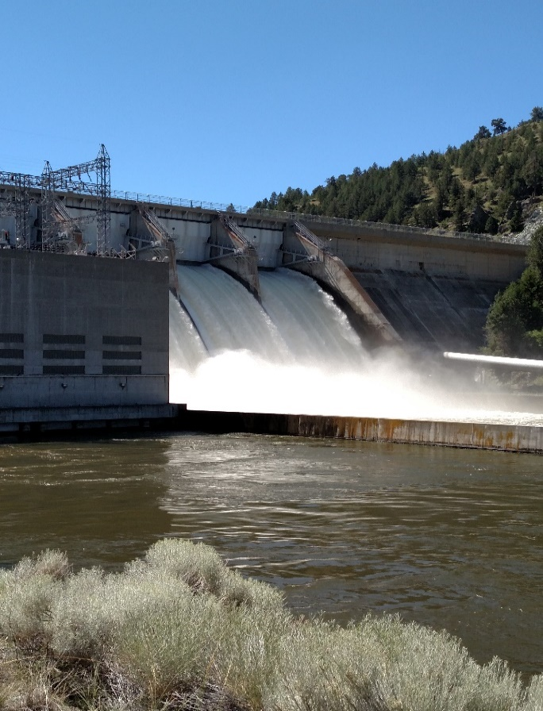

**

2025 ANNUAL

CONFERENCE

**MONTANA WATER RESOURCES ASSOCIATION**

**P.O. BOX 4927**

**HELENA, MONTANA 59604**

**\*\*\*\*\*\*\*\*\*\*\*\*\*\*\*\*\*\*\***

**\*\*\*\*\*\*\*\*\*\*\*\*\*\*\*\*\*\***

**2025 ANNUAL CONFERENCE**

**REGISTRATION**



**FEBRUARY 11-12, 2025**

**FAIRFIELD INN NORTH**

**HELENA, MONTANA**

**\*\*\*\*\*\*\*\*\*\*\*\*\*\*\*\*\*\***